**Practical No. 04**

**Aim: Build a Web App and publish it to Docker.**

Let’s start by creating a new project in the **Microsoft Visual Studio**

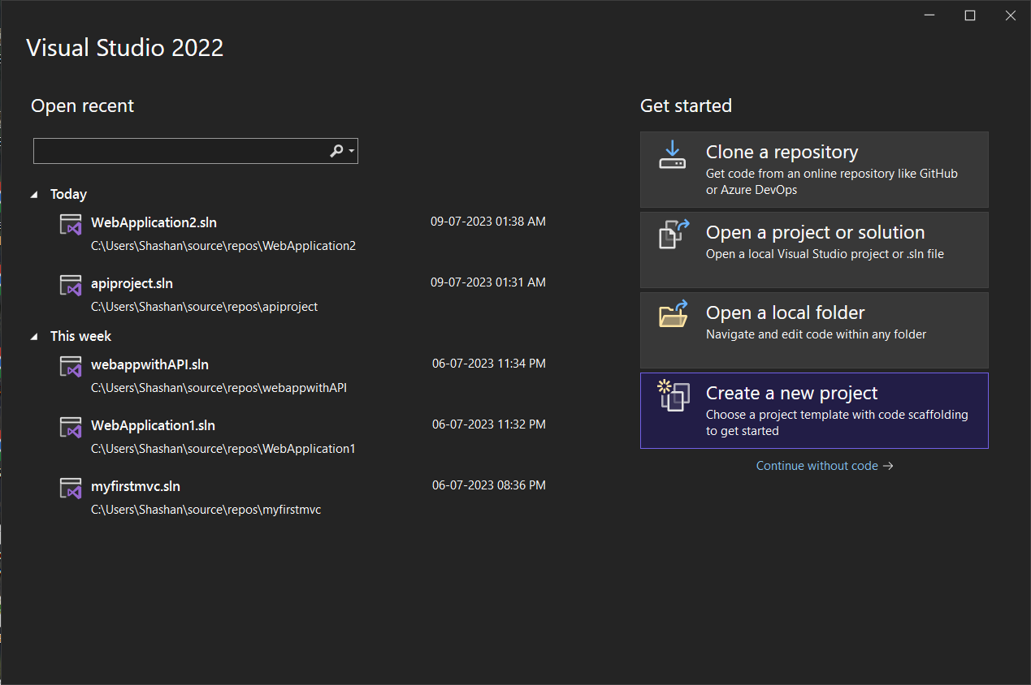

Select the **ASP.NET Core Web App** form the various options.

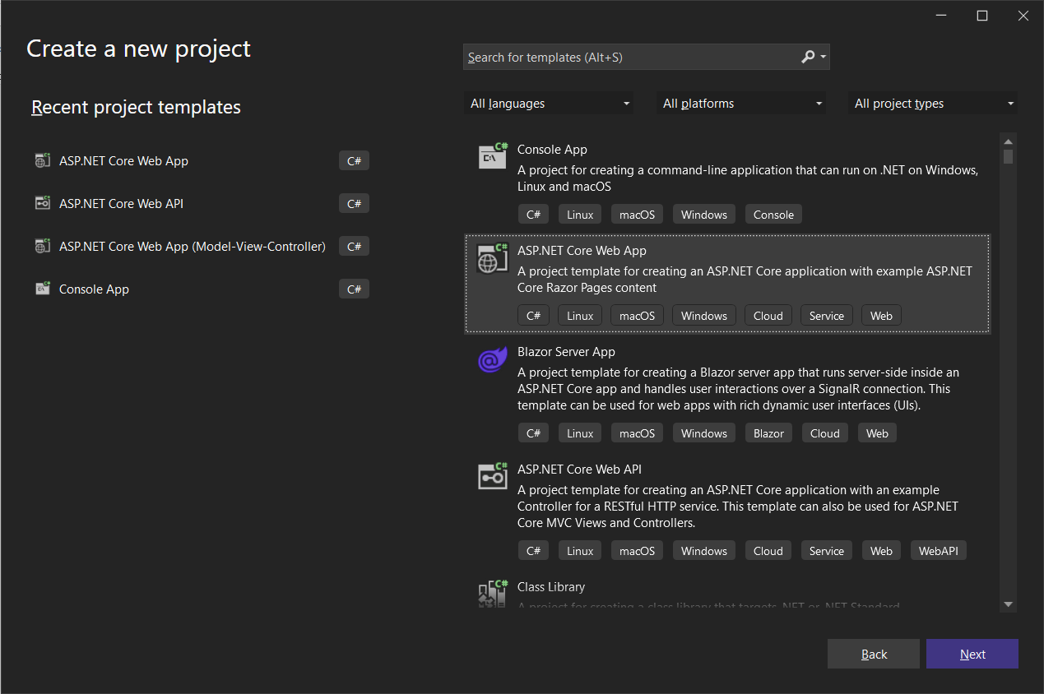

Give an appropriate name to the project.

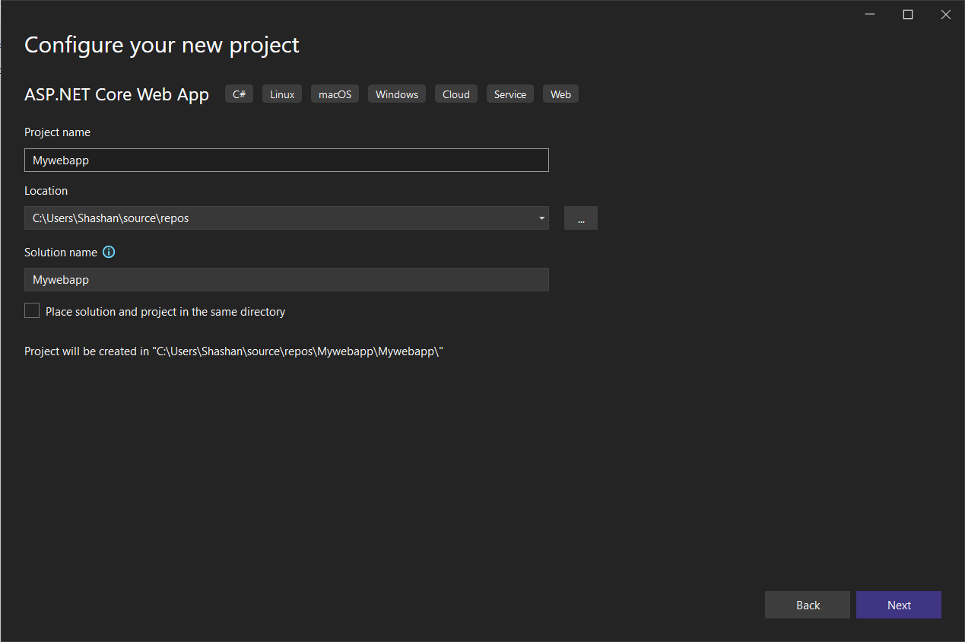

Click on the **Create** button.

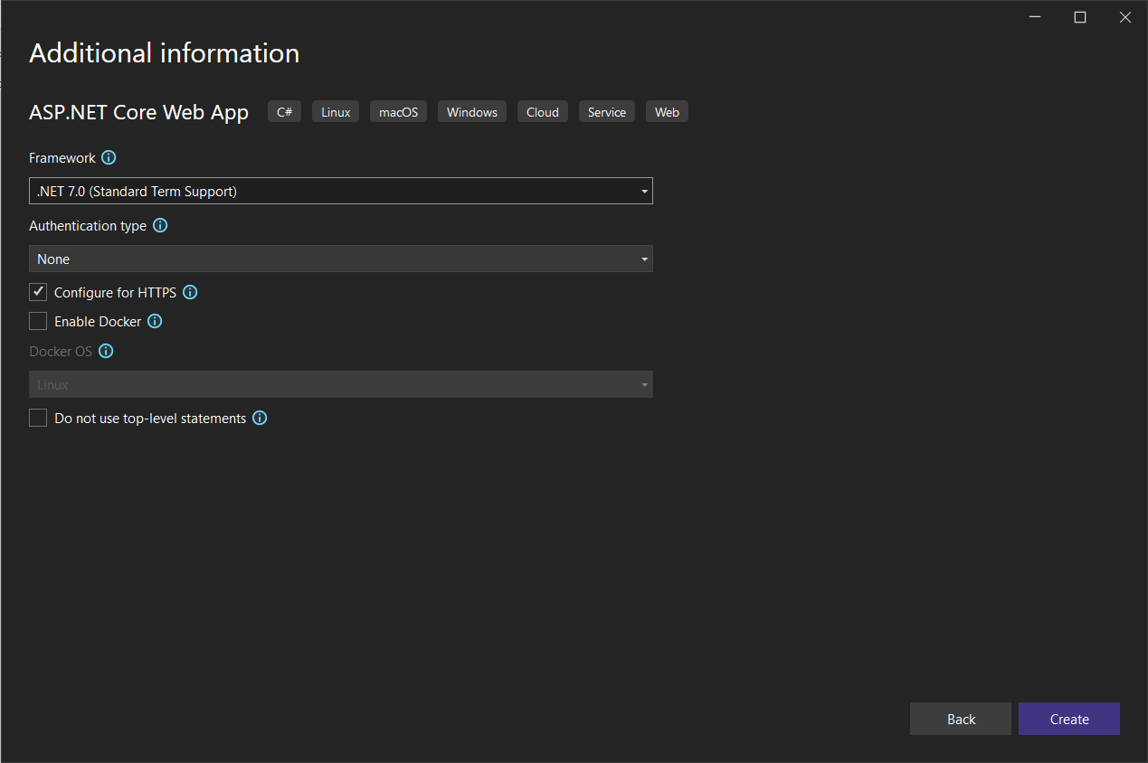

Once the project is created, Try executing the project to make sure that it works.

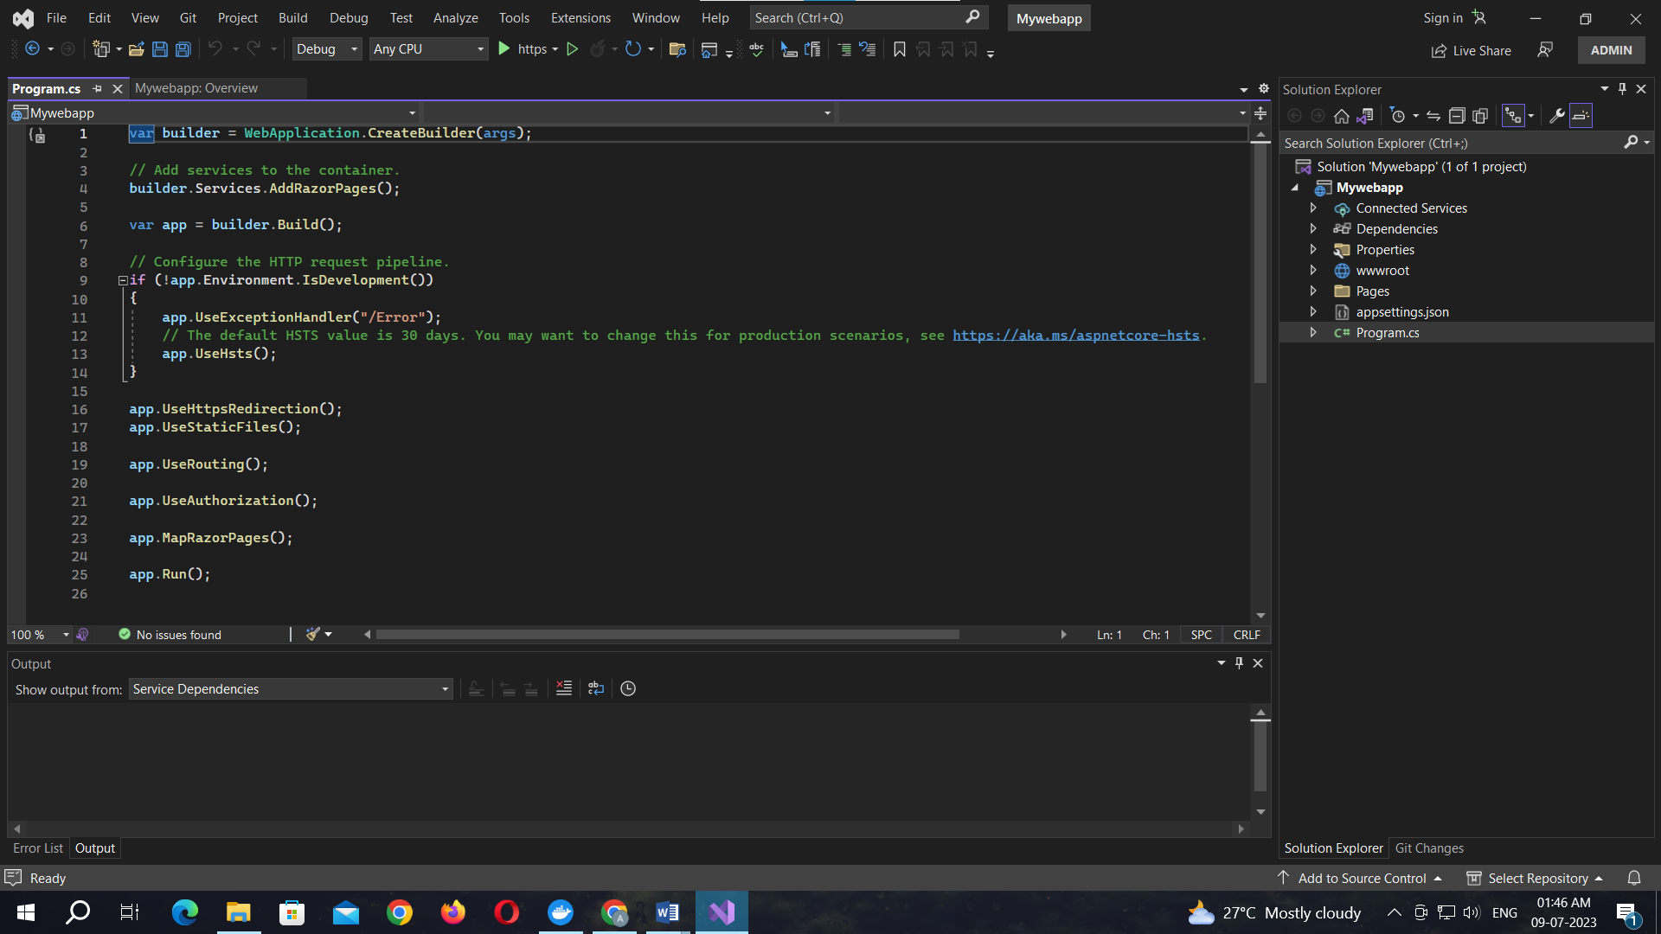

**Output:**

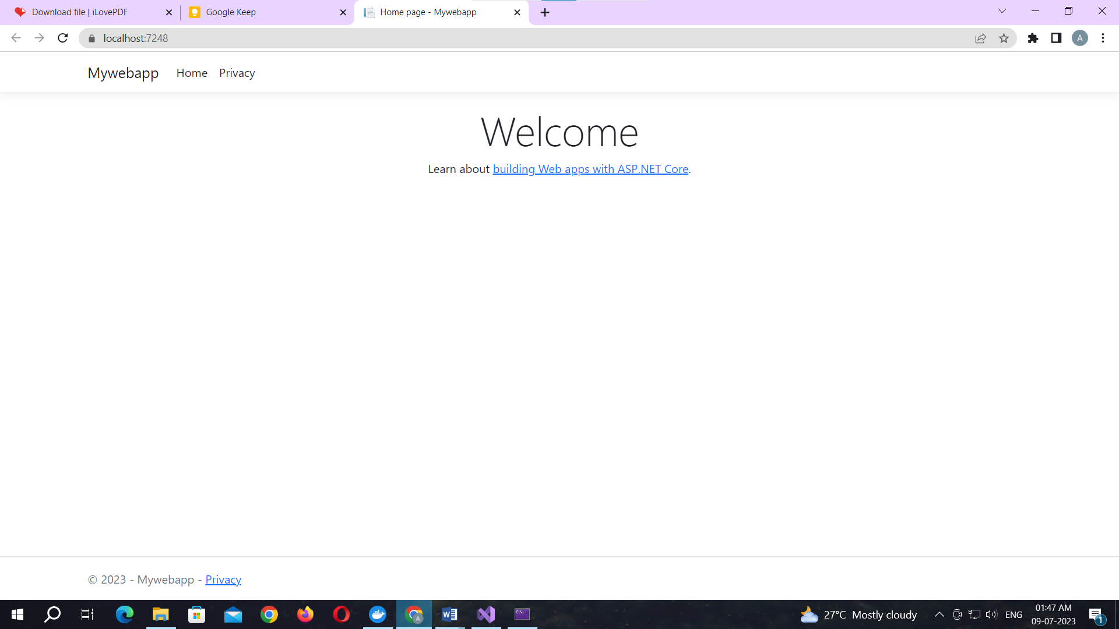

**Right click** on the app name then select the **Add** option form the menu.

Select the **Docker Support** under the **Add** menu 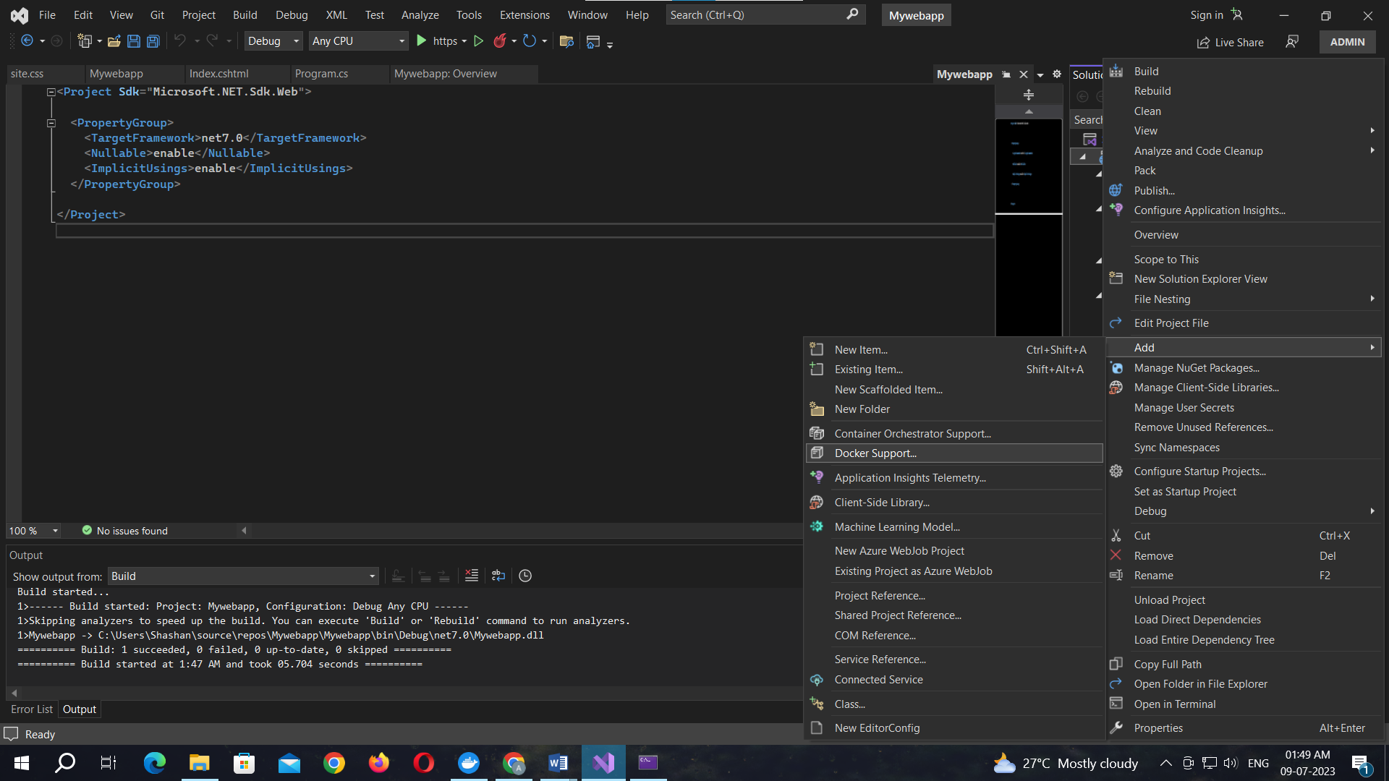

Select the Target OS as Linux and click OK button.

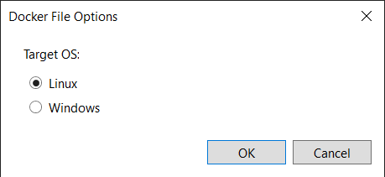

The file naming Dockerfile will appear

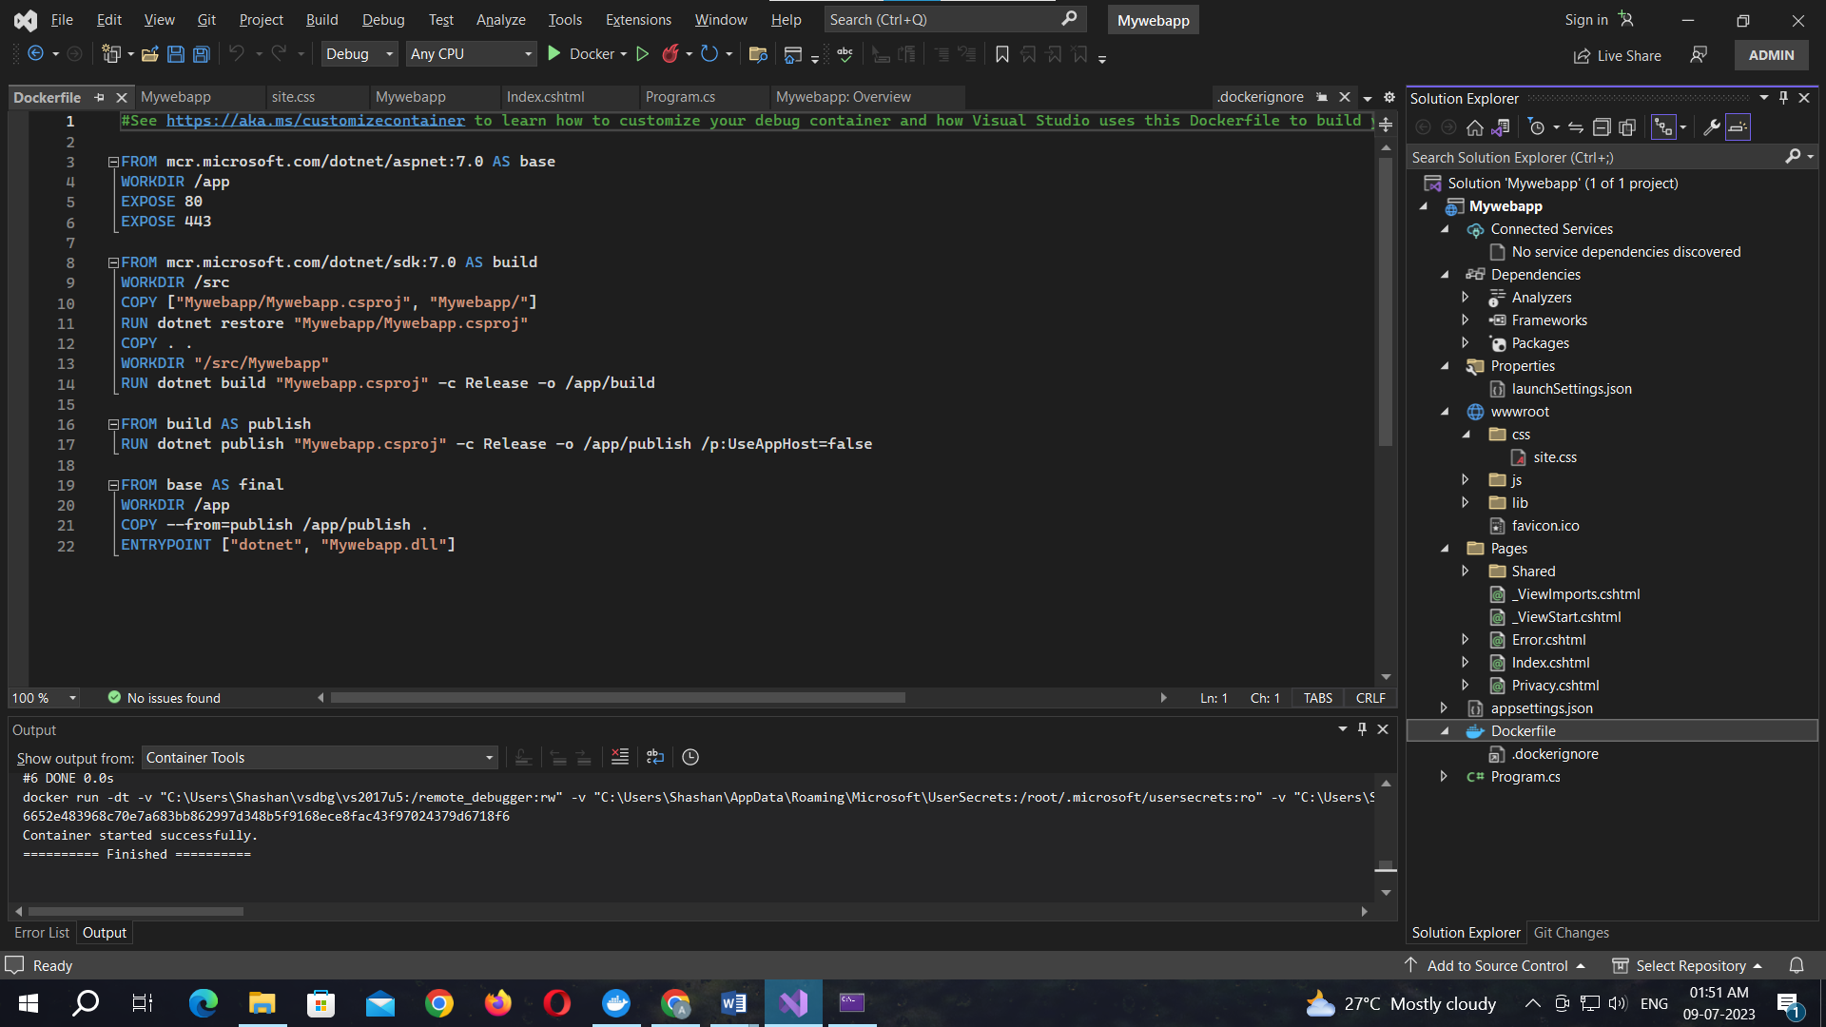

Code for Dockerfile:

#See https://aka.ms/customizecontainer to learn how to customize your debug container and how Visual Studio uses this Dockerfile to build your images for faster debugging.

FROM mcr.microsoft.com/dotnet/aspnet:7.0 AS base

WORKDIR /app

EXPOSE 80

EXPOSE 443

FROM mcr.microsoft.com/dotnet/sdk:7.0 AS build

WORKDIR /src

COPY ["Mywebapp/Mywebapp.csproj", "Mywebapp/"]

RUN dotnet restore "Mywebapp/Mywebapp.csproj"

COPY . .

WORKDIR "/src/Mywebapp"

RUN dotnet build "Mywebapp.csproj" -c Release -o /app/build

FROM build AS publish

RUN dotnet publish "Mywebapp.csproj" -c Release -o /app/publish /p:UseAppHost=false

FROM base AS final

WORKDIR /app

COPY --from=publish /app/publish .

ENTRYPOINT ["dotnet", "Mywebapp.dll"]

The project is uploaded to the docker.

